Ive Planted my Potatoes on the 5th February

After the commercialism and gluttony of the Christmas period is over, it's almost a relief to start thinking about the coming horticultural year, and what successes we might have on the plot in the warmer months to come. Like many gardeners,once into January, I tend to get extremely impatient for the horticultural year to begin in earnest, and I start to plan-out what crop varieties I will grow, how I will rotate the beds, and when I will start to sow seeds, etc, etc. This year, I have decided to try for an extra-early crop of first earlies.

The reasons for this are twofold: Firstly, with a crop planted in early February, I can potentially start lifting baby potatoes between May and June (all being well). This means that I can then re-plant the bed with a brassica or bean crop. Secondly, hopefully I can limit some of the impact of potato blight, which tends to come in around the end of June, and into July.

So, with my plans being made, I went out and bought seed potatoes at the end of January. The varieties I went for were Ulster Sceptre, Lady Cristyl, and Caledonian Pearl. I wish I could say that I had done a great deal of research into these varieties, and found them to be the most reliably hardy for this experiment; but really, the truth is I just fancied giving them a go.

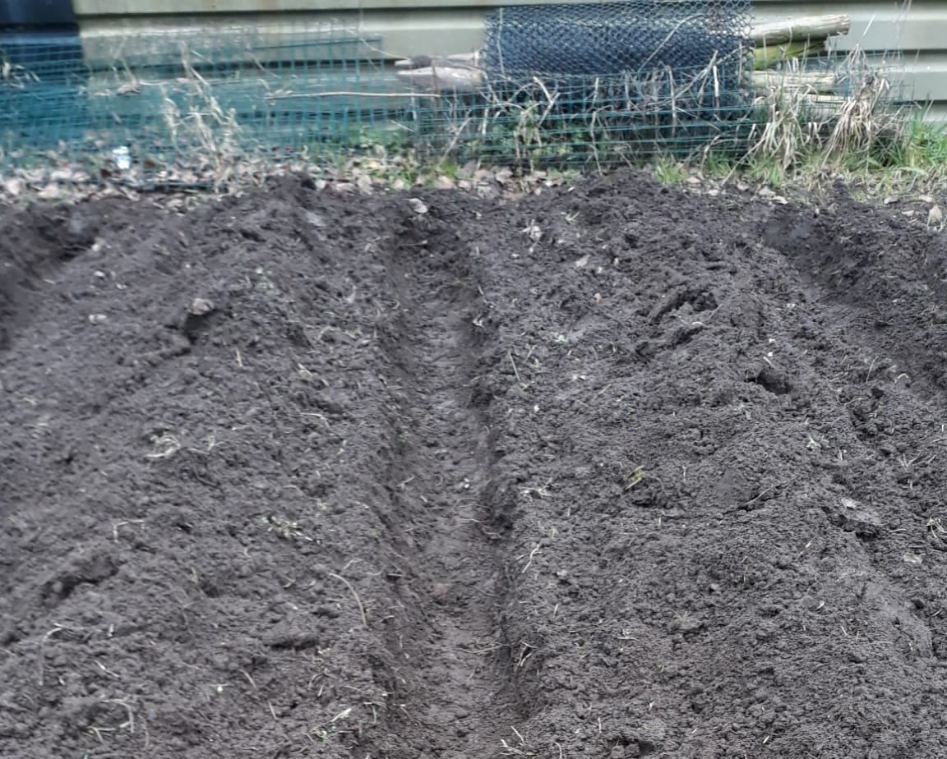
Trenches were rotorvated and dug to 9 inches deep. Into these, I placed a 2 inch layer of insulating straw (4.99 a bale from Kenyon Hall Farm). I added potato fertiliser at the recommended application rate (£5.99 for 2.5kg, NWGA), and placed the tubers 15 inch apart.
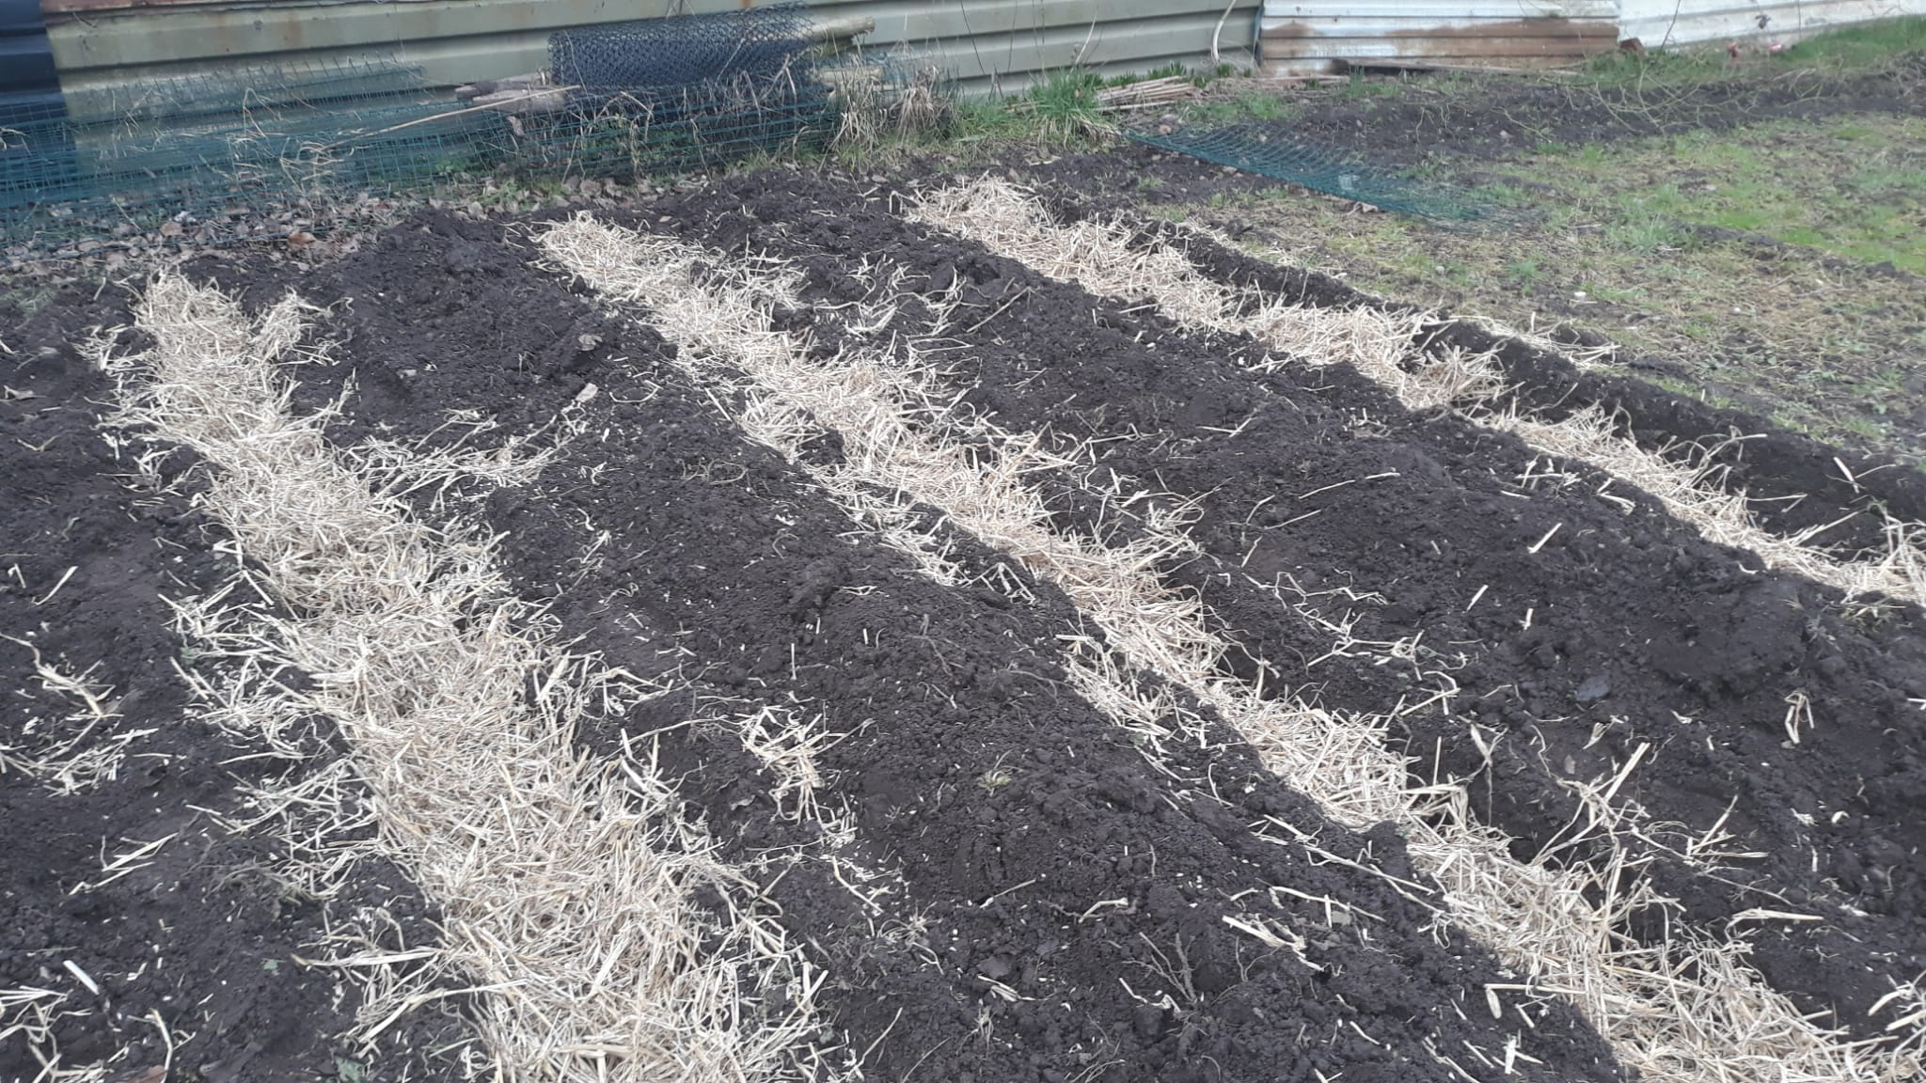

After watering the tubers in, the trenches were back-filled level, and another 2 inches of insulating straw were placed on top. The trenches were then finally earthed-up to 10 -12 inches above soil level (please see pictures attached). Hopefully, this will be more than enough to prevent the tubers or haulms becoming frosted.

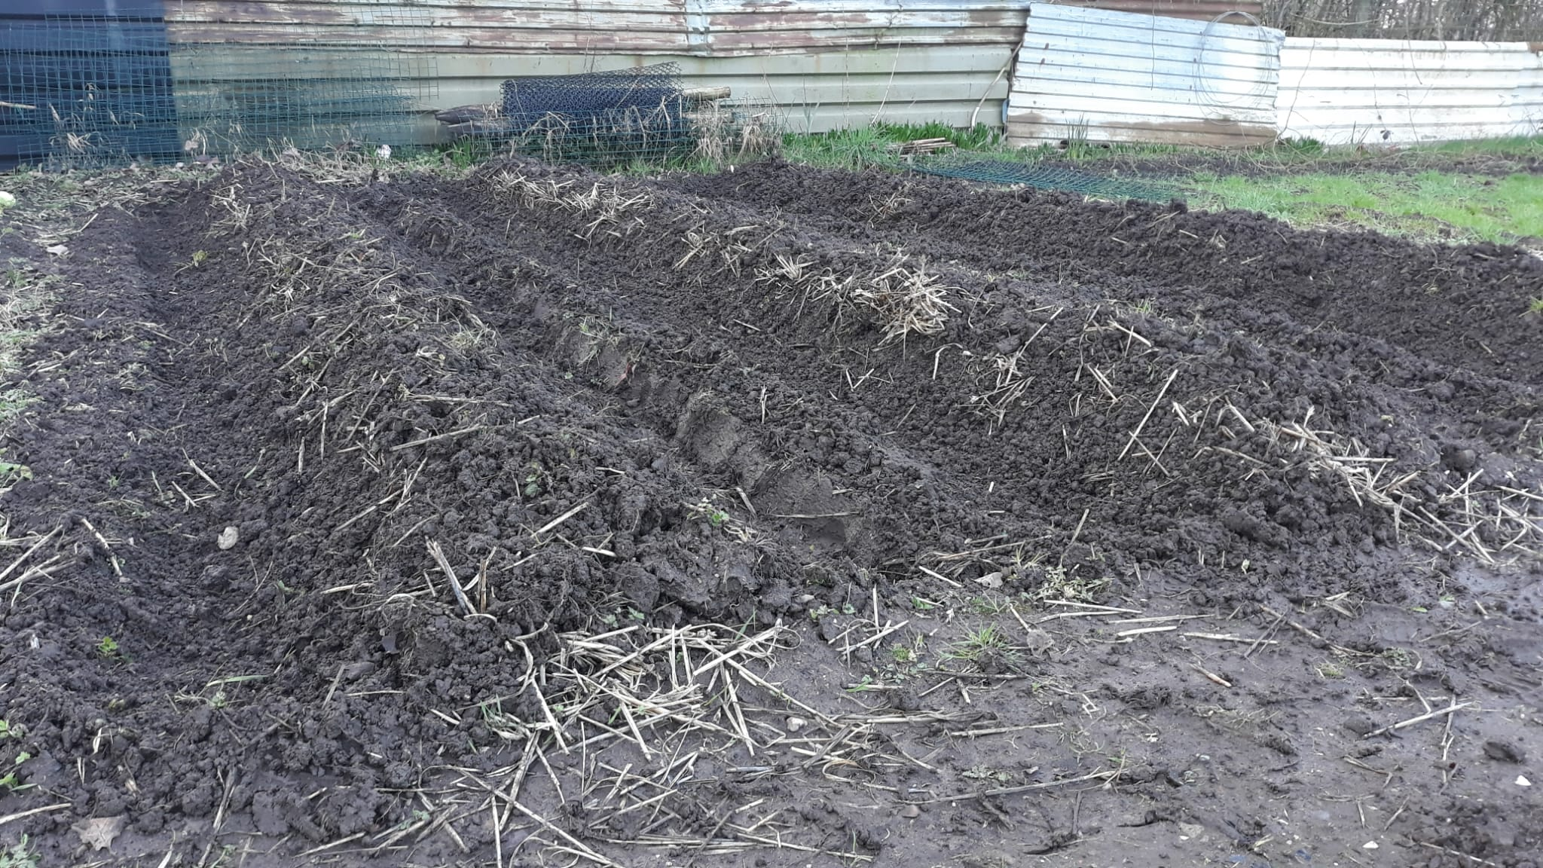

This trial will either prove that, with a bit more care and attention than usual, a viable crop of potatoes can be produced 6 - 8 weeks earlier than we would normally hope to achieve.

Or, it will prove to be a terrible failure, never to be repeated again. Planting potatoes on the 5th of February absolutely goes against the received wisdom of centuries of horticultural practice; but sometimes conventions need to be challenged, just to see if they still hold true.

I will continue to provide updates as the season progresses.

Karl Horne
Plot 56

